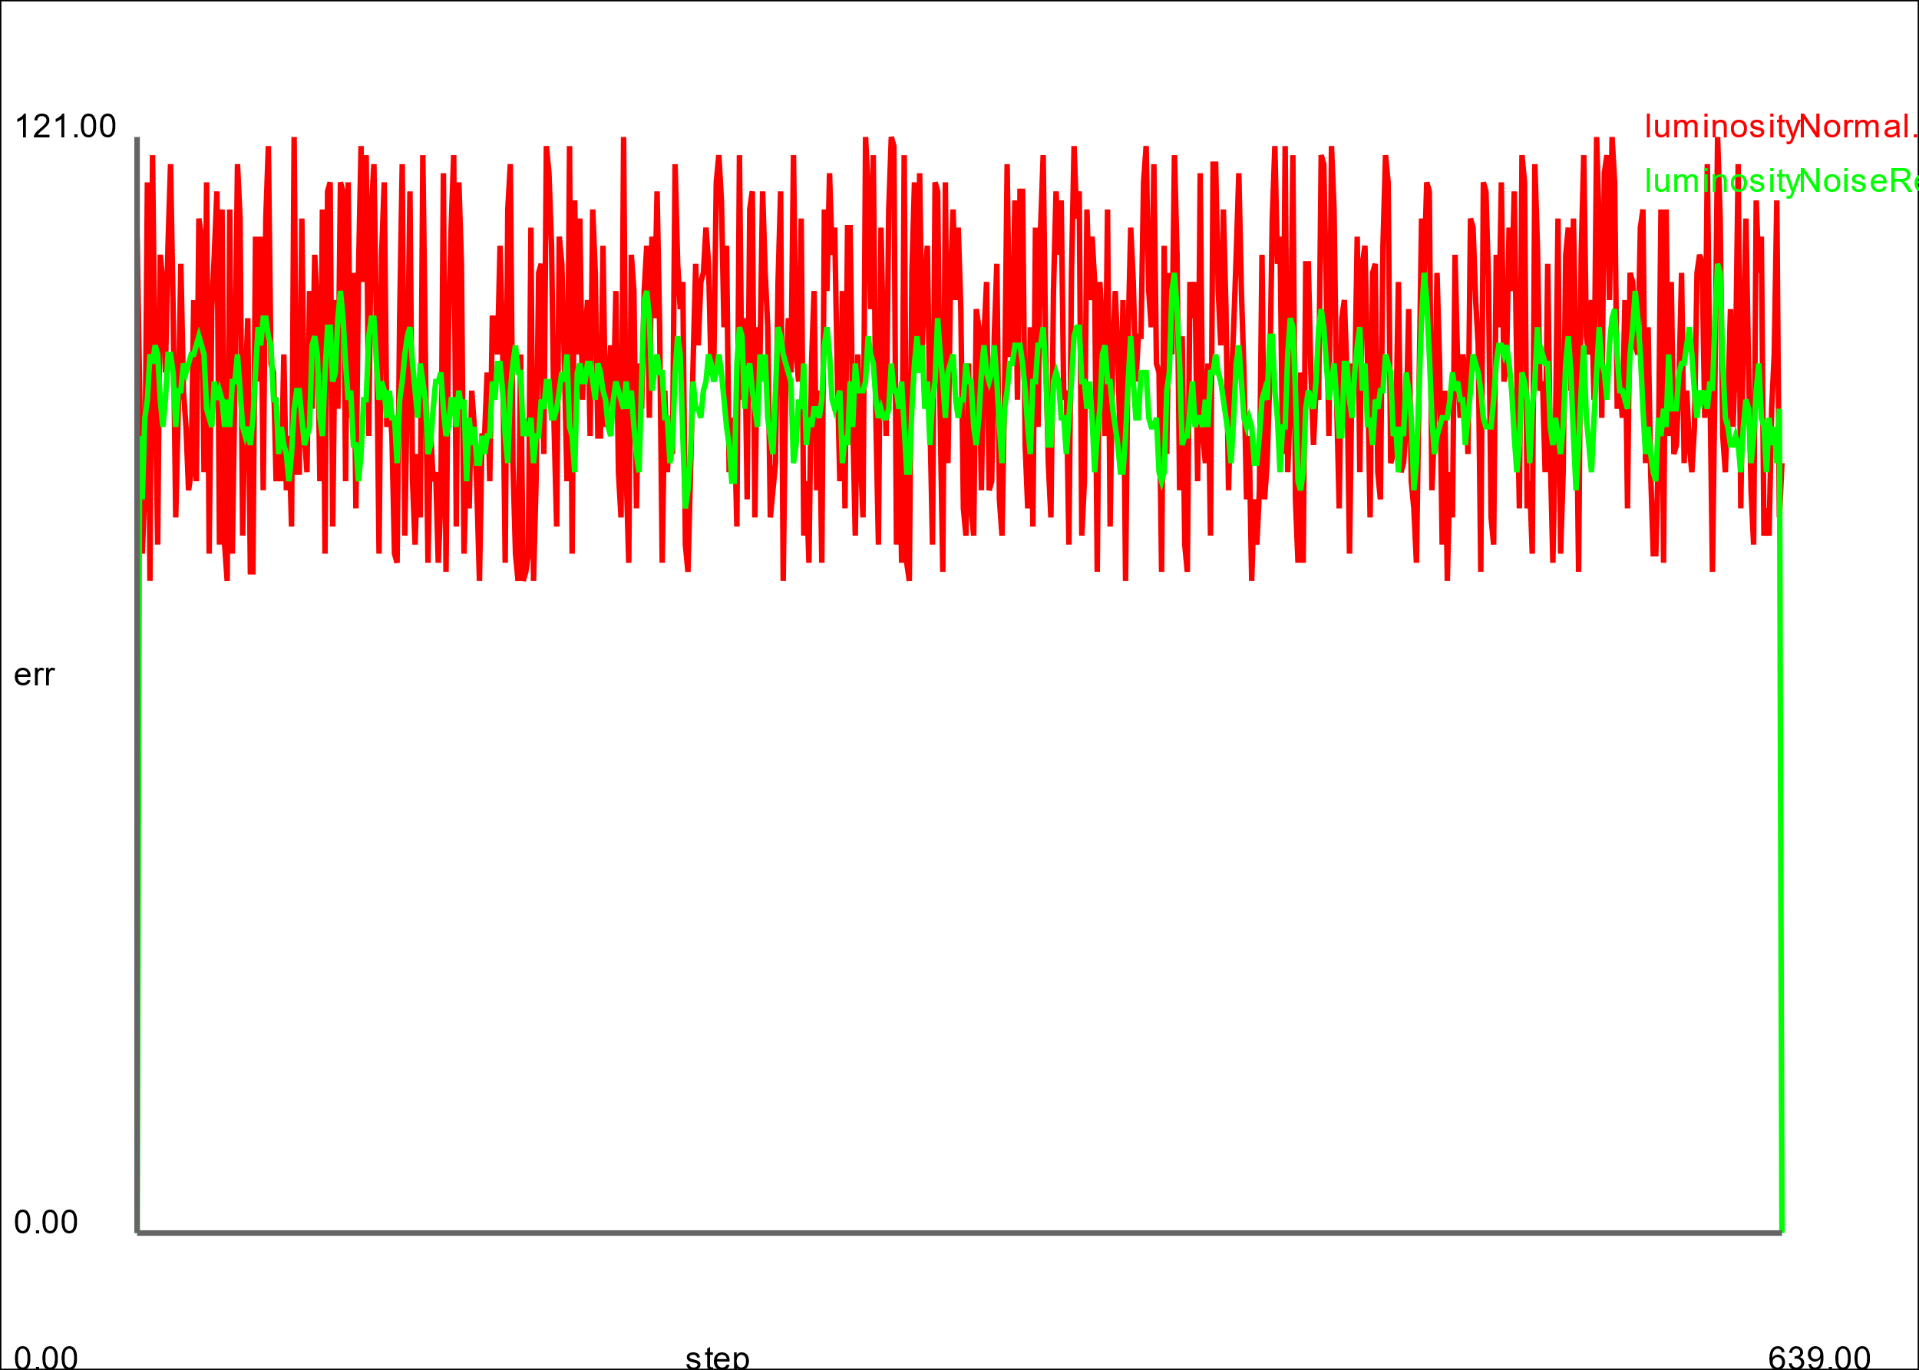

In the graph above, you can see that the luminosity values of the picture with noise is significantly higher than the one with the filter added to it. This is because of all the white spots in the photo making the value spike suddenly. This isn’t as bad as the one with the filter added to is, but it still has some lighter spots compared to if the image was just plain black and grey like how it should be. With these lower spikes however, it becomes easier to detect what we are looking at in terms of the image.